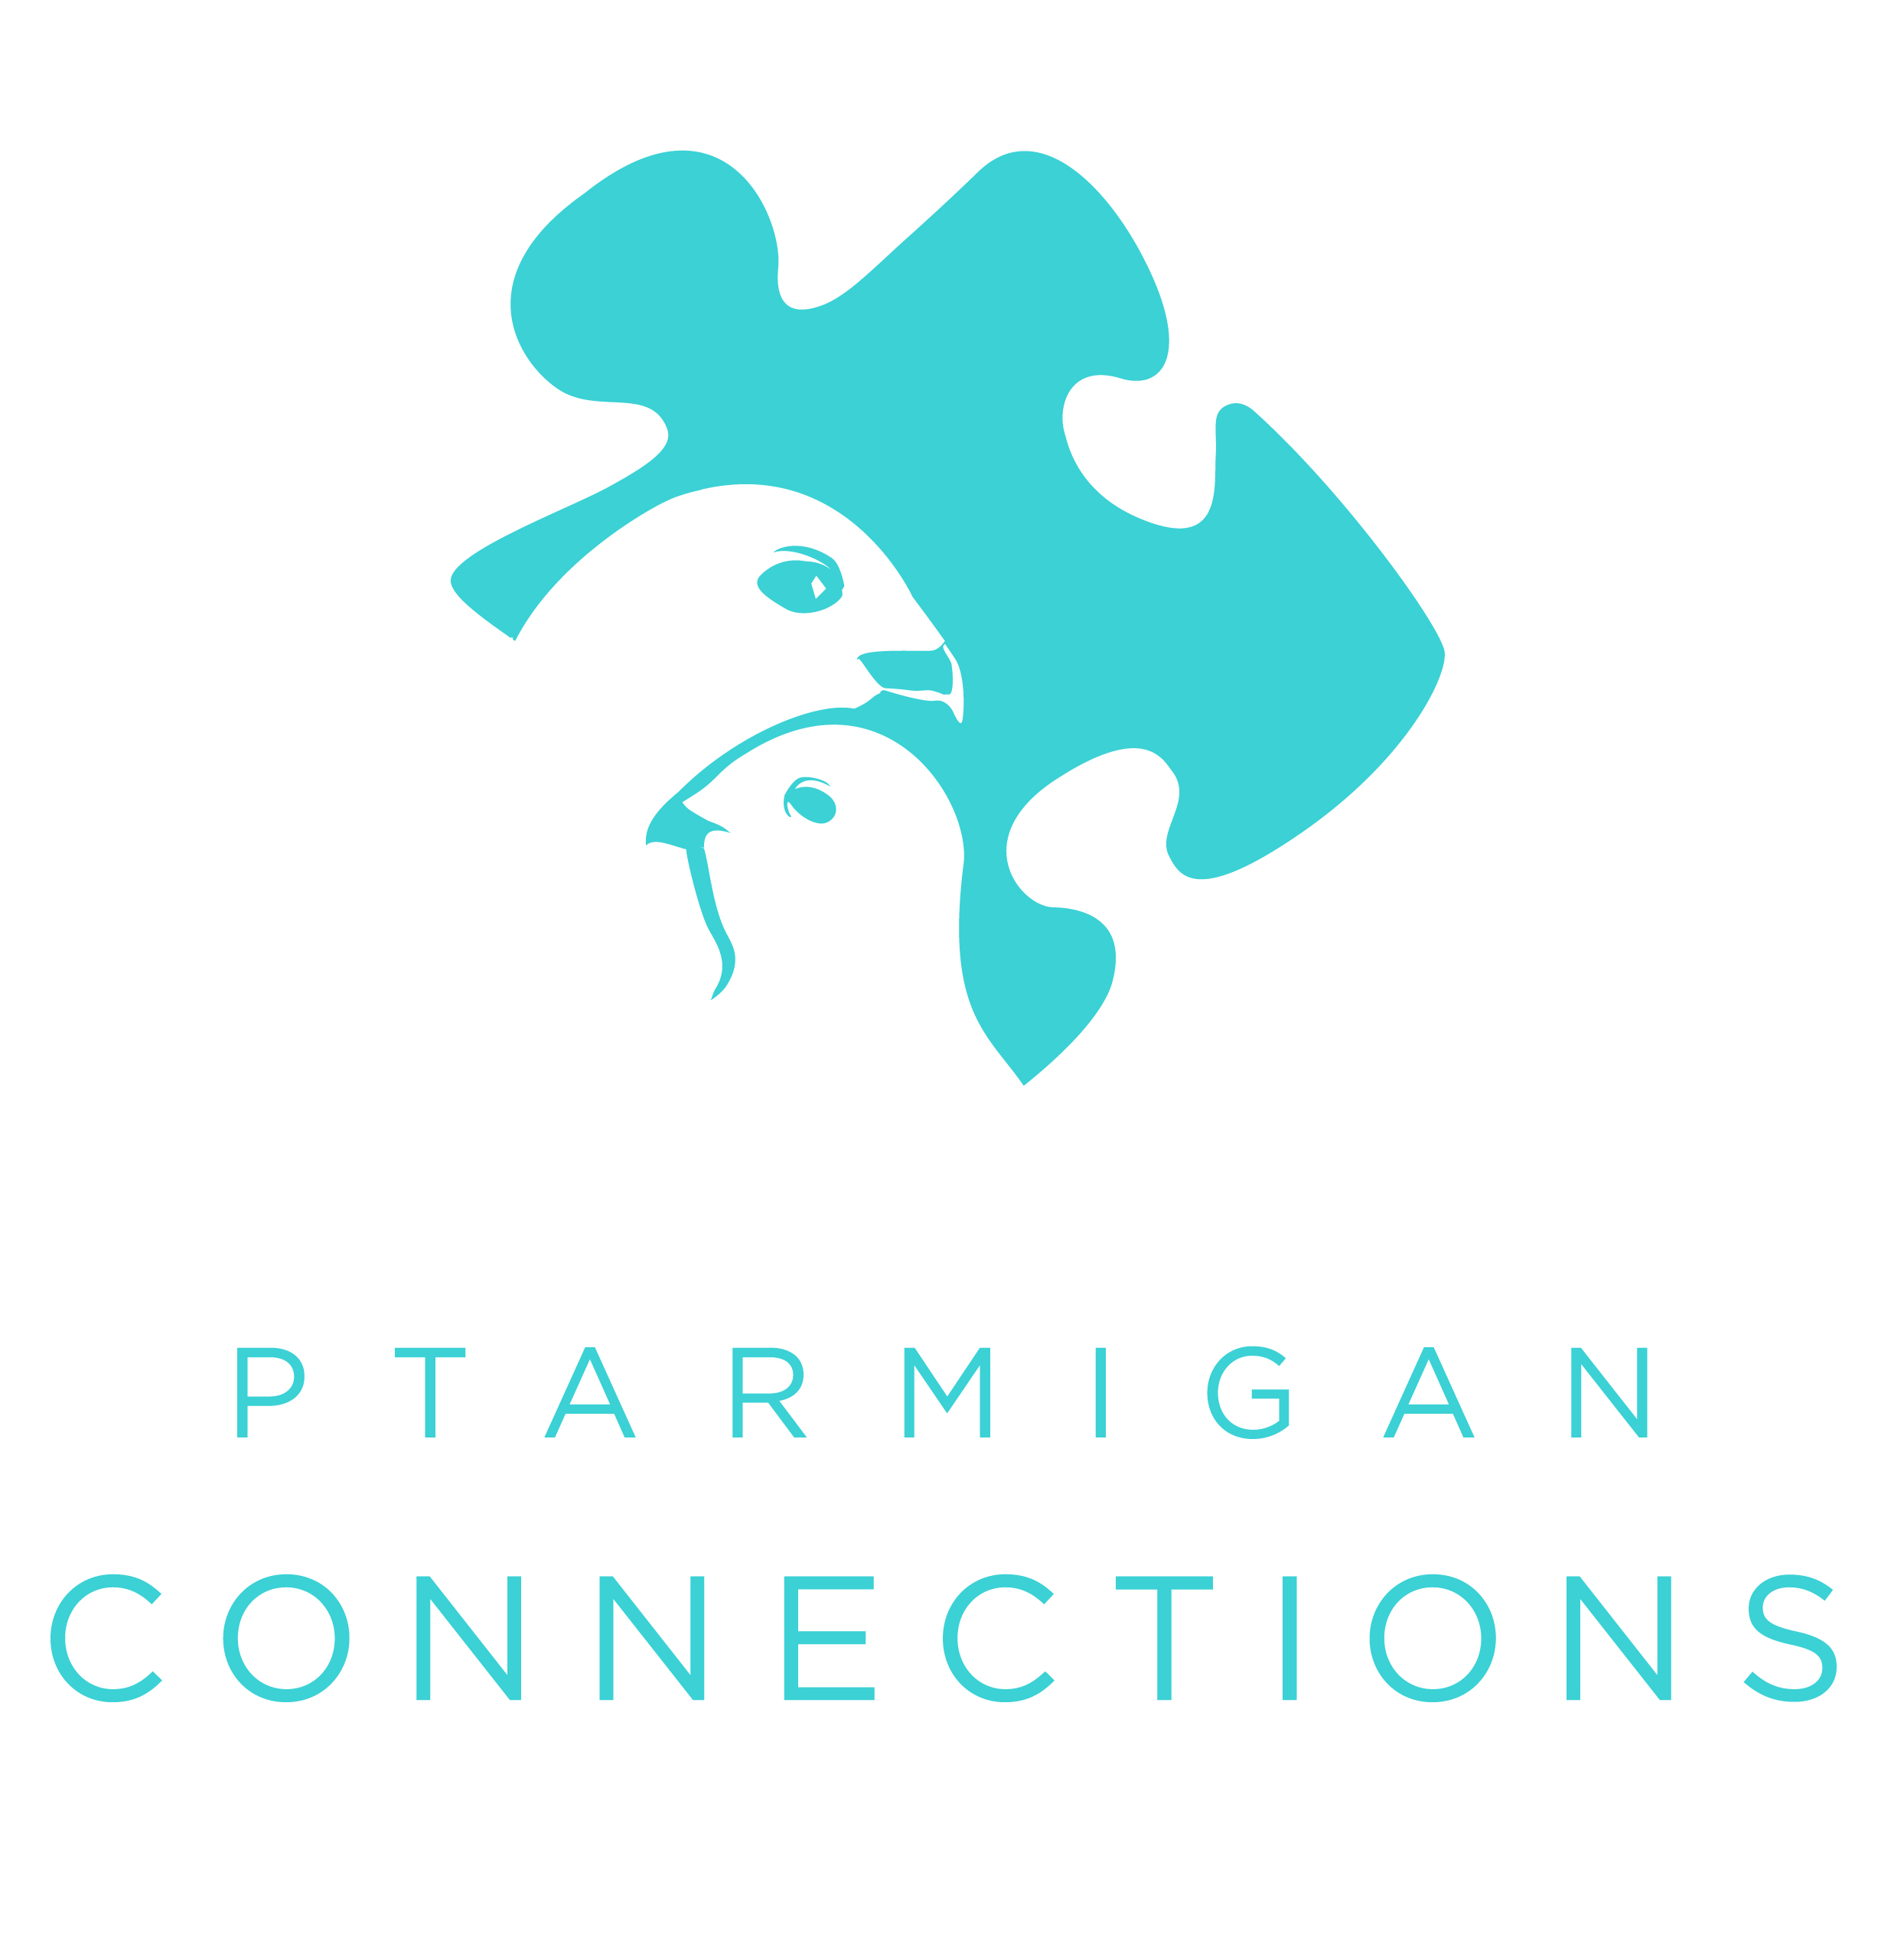
Ptarmigan Connections
3505E Meridian Park Lp, Ste 200
Wasilla, AK 99654
907-357-4400 (office)
907-357-4410 (fax)
ptarmiganconnections.com

REFERRAL FORM
Please provide as much of the following information as possible.
Please let your patient know we will contact them within 2 weeks.
Date of referral:
Patient last name: First: MI:
Date of birth: | Gender:
Parent/guardian name: | Best contact phone(s):
Address: | Insurance Plan:  Policy #:  Policy holder name:
Referral Question  Please describe specific problems/symptoms and diagnoses: | Category of Request (Check all that apply):  Developmental Consultations  High Risk/ Complexity Case Consultations  Fetal Alcohol Spectrum Disorders (FASD) Diagnostic Evaluations  Autism Evaluations  Psychological and Neuropsychological Evaluations  Psychiatric Medication Management  Behavioral Health Counseling  Group Therapy  Speech and Language Therapy  Feeding and Swallowing Management  Other:_________________________
Previous/current relevant health or mental health history (include duration of symptoms):

ICD-10 Code(s) (for insurance prior authorization):
Does the patient have any of the following limitations: (check)
Communication Language Vision Hearing Physical Disability History of Head Injury
Requesting provider: |  | Primary Care Provider Other
Best contact number: 907-357-4543 |  | Fax: 907-357-4533

Referring Provider Signature:

Today’s Date:
***Please send any recent chart notes, history and physical reports, or discharge summaries.

