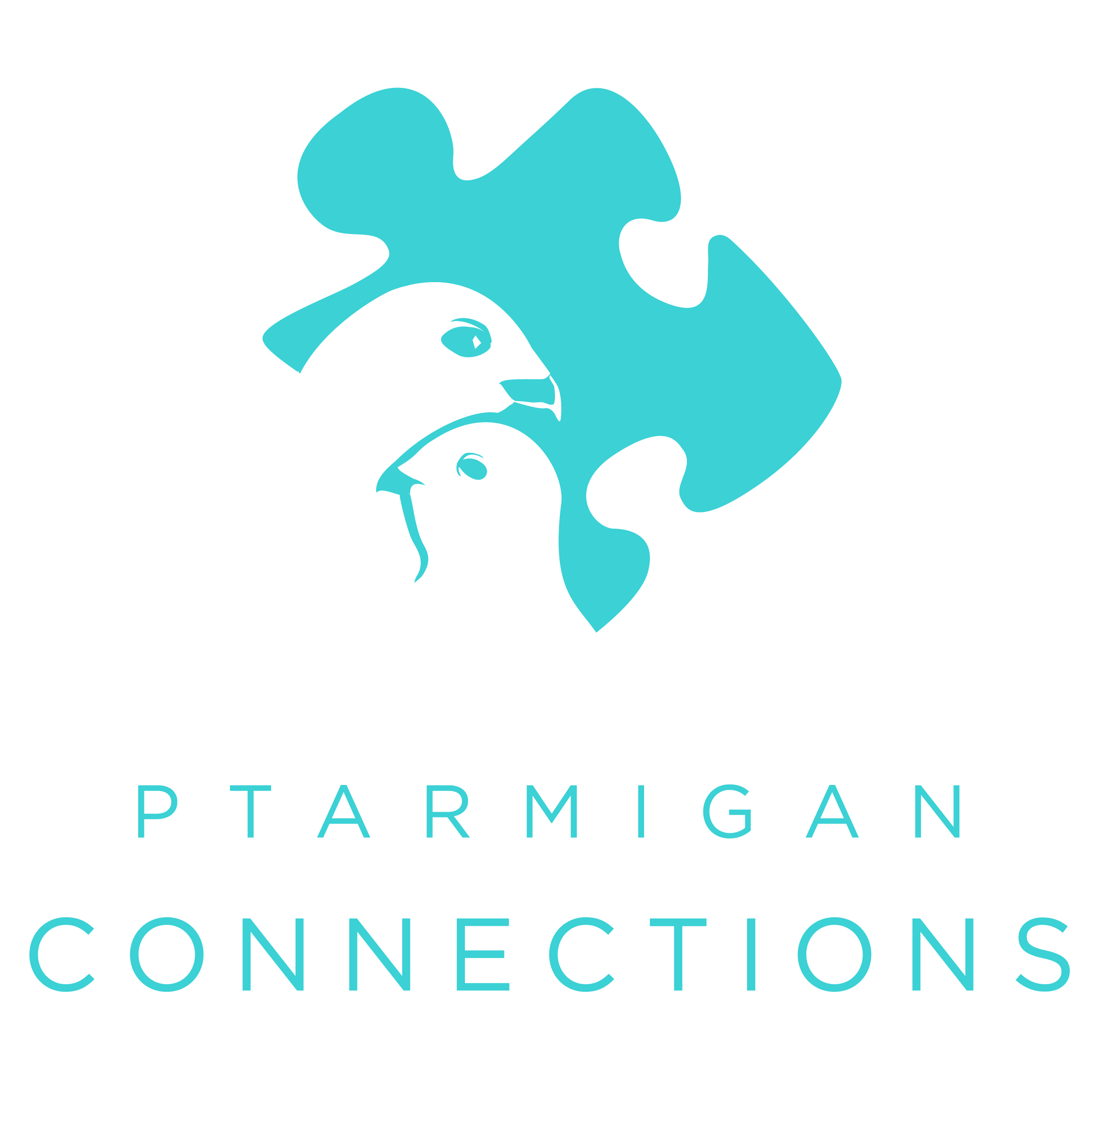
Ptarmigan Connections
3505E Meridian Park Lp, Ste 200, Wasilla, AK 99654
907-357-4400 (office) 907-357-4410 (fax)
ptarmiganconnections.com
Patient Registration Form
Mother □Bio-mother □Stepmother □Guardian □Other:_______________________
Full Name____________________________________ SSN _____________________________ DOB _________________________
Mailing Address ________________________________________________________________________ Zip code ______________
Physical Address ________________________________________________________________________ Zip code ______________
Home/Work (circle one) Phone ____________________________________ Cell Phone ____________________________________
Email: _________________________________________Preferred Contact Method: □ Home Phone□ Cell Phone□ Work Phone
Father □Bio-father □Stepfather □Guardian □Other:________________________
Full Name____________________________________ SSN _____________________________ DOB _________________________
Mailing Address (if different than above) ____________________________________________________ Zip code ______________
Physical Address ________________________________________________________________________ Zip code ______________
Home/Work (circle one) Phone ____________________________________ Cell Phone ____________________________________
Email: _________________________________________Preferred Contact Method: □ Home Phone□ Cell Phone□ Work Phone
Preferred Pharmacy _____________________________________________________________________
Family’s Preferred Language (although we cannot guarantee we can communicate with you!): □ English | □ Other: _____________________
*** INSURANCE INFO (present card(s) to front desk) □ Self Pay **THIS SECTION MUST BE FILLED OUT**
Primary Insurance Company:____________________________ Policy#:_____________________ Group#:__________________
Policy Holder’s Name: ___________________________________SSN: _________________________ DOB: ____________________
Secondary Insurance Company: ____________________________Policy#:_____________________ Group#:________________
Policy Holder’s Name: ___________________________________SSN: _________________________ DOB: ____________________
1. Child’s Full Name _________________________________________ Date of Birth __________________ Gender: □ M □ F
Primary Race: □ African American, □ Alaska Native, □ American Indian, □ Asian, □ Caucasian, □ Hispanic, □ Pacific Islander
Ethnicity: □American, □ Inuit/Eskimo, □ Canadian, □ Russian, □ Ukrainian, □ Iraqi, □ Other: _________________________
2. Child’s Full Name _________________________________________ Date of Birth __________________ Gender: □ M □ F
Primary Race: □ African American, □ Alaska Native, □ American Indian, □ Asian, □ Caucasian, □ Hispanic, □ Pacific Islander
Ethnicity: □American, □ Inuit/Eskimo, □ Canadian, □ Russian, □ Ukrainian, □ Iraqi, □ Other: _________________________
3. Child’s Full Name _________________________________________ Date of Birth __________________ Gender: □ M □ F
Primary Race: □ African American, □ Alaska Native, □ American Indian, □ Asian, □ Caucasian, □ Hispanic, □ Pacific Islander
Ethnicity: □American, □ Inuit/Eskimo, □ Canadian, □ Russian, □ Ukrainian, □ Iraqi, □ Other: _________________________
4. Child’s Full Name _________________________________________ Date of Birth __________________ Gender: □ M □ F
Primary Race: □ African American, □ Alaska Native, □ American Indian, □ Asian, □ Caucasian, □ Hispanic, □ Pacific Islander
Ethnicity: □American, □ Inuit/Eskimo, □ Canadian, □ Russian, □ Ukrainian, □ Iraqi, □ Other: _________________________
**** If you have more than 4 children, please see the front desk for an additional page****

Signature of parent or legal guardian: _______________________________________ Date: ___________________

Printed name of Parent of Legal Guardian: __________________________________________________

Ptarmigan Connections
3505E Meridian Park Lp, Ste 200, Wasilla, AK 99654
907-357-4400 (office) 907-357-4410 (fax)
ptarmiganconnections.com
HIPAA Acknowledgement, Office Policies, Assignment of Benefits
*If you are submitting this remotely, please mail/fax this completed form with a copy of Insurance & ID card(s) to the address at the top of this page.

By signing below, I, _________________________________________________________________, hereby…
(Printed name of parent or legal guardian)

- …acknowledge receipt of or access to Ptarmigan Connections, HIPAA / Privacy Notice and recognize that changes to this policy may occur at any time without notice. I will always have access to the most recent Notice at the clinic website: www.ptarmiganconnections.com, or posted in the clinic office waiting room. I may request a written copy at any time.

- …believe that Ptarmigan Connections, is committed to providing the highest quality medical care for my family members aged birth through 17 years.
- …commit to canceling appointments with as much notice as possible, and understand that failure to notify this office of my inability to keep any appointment will result in a “no-show.” Repeated no-shows are serious and may involve a fine which must be paid prior to the child being seen again in this clinic, acceptance at the clinic on a walk-in basis only (as time allows), or both. Insurances do NOT cover no-show charges. Patients over 15 minutes tardy may be asked to reschedule.
- …understand that Ptarmigan Connections is proud to be a mentoring / training facility for students in health related fields, who may provide care to my child under the supervision of the licensed clinical staff.
- …agree that my child cannot be seen in this clinic without a parent or legal guardian (or my representative designated in writing) being present. “Guardianship agreement” forms are available in our office or via download on our website.
- …authorize Ptarmigan Connections, to submit claims to my child’s insurance company(s) on my child’s behalf, and my child’s insurance company(s) to pay benefits directly to Ptarmigan Connections.
- …understand that should any insurance payment be made directly to me for monies due on this account, I agree to immediately pay over these funds to Ptarmigan Connections.
- …understand that an “out-of-network” insurance carrier may limit payments for any or all services provided by Ptarmigan Connections, regardless of the advertised benefits package. (i.e., they may pay less than our standard charges, even if they advertise “100% benefit”).
- …agree that upon acceptance of services provided by Ptarmigan Connections, I assume responsibility for any deductible, co-pay and coinsurance, as well as any other balance not covered by my child’s insurance carrier. Copays and estimated coinsurances are due at the time of service. If my account is turned over to Cornerstone Credit Services for collections, I agree to pay any resulting collection and legal fees.
- Furthermore, I understand that if I personally pay all billed charges in full at the time of service, I am eligible for “prompt-pay/self-pay discount.”

Name(s) of Children / Patients: ________________________________________________________________________
Printed Name of Parent or Legal Guardian: ______________________________________________________________
Signature of Parent or Legal Guardian: _____________________________________Date: _________________________________

